[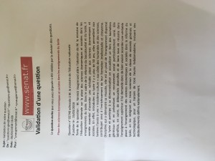](https://www.apses.org/version2015/wp-content/uploads/2018/03/IMG_0096.jpeg)